0,
EAq}ABAZ}E ^{(MSDS)}
1
71. +.
s}trlAl+4 cl^}"il _{-tl} ^{lf ?')} .^llEu
4l+g ^{A.n. +Ee+} ^i+,*el
*a1xd_u
6cd
-u
,{l*
^{HIA} E+ +++ szlr-l
_{^l+el} a:il 8E
^{xrl+el} ^)*+E ^{xll+}
rl. _{TtrzI 4B}
E]^}H
z)- _{l+}
dslHa
2. +811.+lEc
zl. _{fr"ia":.+l€^d} g.+
qAs4,}zl _{4C1E$} uE) : +82 i+. ^{qlEla:lE+E} s.+* dlrxl ^{a.r$} ^{:u} BEzI
dEq
At_{+4.+l'€E+}
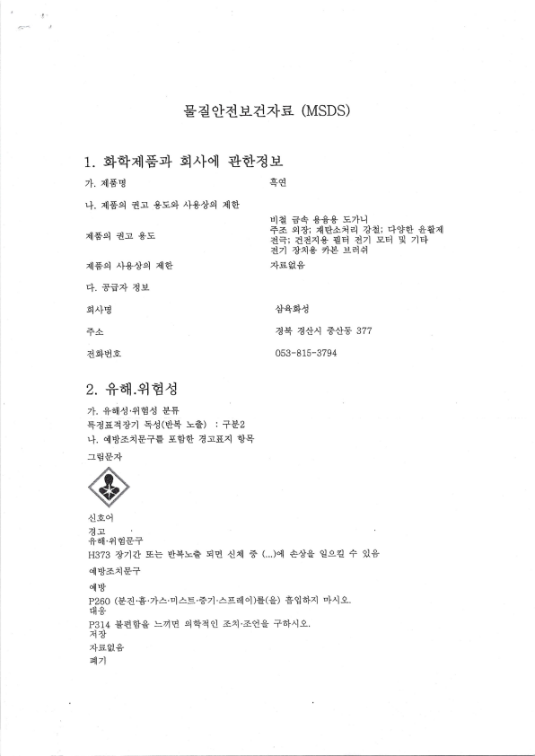
₊₌ slt; zXEl:i4 z*'l;4*'J ^{s"q+41} dt; ddxl+ ^{gEl} dzl s-el 4 zlel dzl *i* zlB salf
zle9*
+qqc
d4 ^{zdtlrl} +*+ 377
053-8 15-3794
HBTI *71rt !1ts _{HI+t=€} ^{qE} dil + ^{(...)ql} +^Jg ^{oJga} + 9l+ 4l%r=x197
qlt"I
p260 (Bd.E. z|+. ^{u1 -,- e . +71.} ^ ^{gell ol} )E(g) + _{"J} dlzl r|{ g.
Erl+
^{p314} +BB€ _{=zlB} E€l4oJ azl'atg ^{+6I^19-.} ,1* zie$.*
qlTl
_{P501} (+a _{H+ql} 4. +it1C ^{.+lB} C !-a 1 El-rI 1 Rl*^d 0
B^lg ^{LI+.ll trl+)} _{'ll+tr} *zlE ^{ql7l6l^lg.} Efizlfql .Eq+gzl e*= ^{zlEl} +4C'qB^d(NFPA)
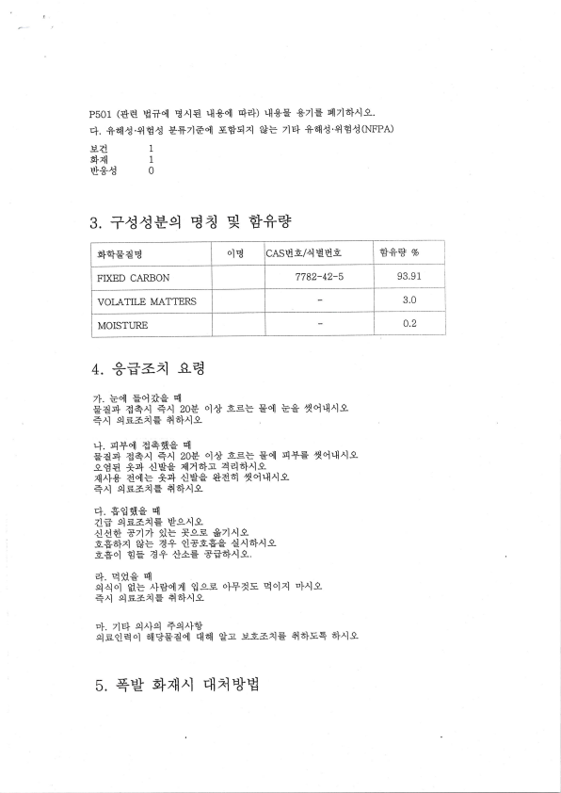
3. +ccBq _{Ea} q _{++=&}
E}'+EAB ^{olB} CASBE/4 _{EHA} EJ** _{v,} FIXED _{CARBON} 7782-42-5 93.91 VOIATILE MATTERS ^{3.0} _{MOISTTJRE} 0.2
4. *Ea=1 s-?B
^{7I.} _{=."{ Eqr^}g} q
Ear+ d+^l +^l 208 ^{o]^J E.s=} Eql Eg 4ol,llrlg +^l ^{e.ls-a^lE} Aal^l9
+. ^{sl+ql} _{d+qqg} q
Eaq d*al ^{q,rl 208 ol+} -6s= ^{Eql} q+E _{4ol.tlrl-q} s-g€ *r+ d$g 4lAs}:il ^{44zs}^ls} zllrl* a{= *q dgg SA61 4olqlalg
+^l ^{elEarlE.} a6I^19-
^{trI.} +'Jflg ^{q}
Z? ^{gE-axlE *s^l-q} dd+ 87171 9lE *g=- *zlrlg
E=.olxl 9+= A+ _{"J*E=.9} d^lsl^]9-
E*ol eE a+ 4}}E ^{'31;ia|{9.}
^{?+.} E Hg ^{ql}
94ol $.= _{^I+"llAl} Ess ^{dI+aE} Bol^l ^{EI^]-Q-}
+^l ^{el} =-azl$ ^{A} 8l^lg
_{"I.} zl4 el^lel _{+E^I5J}
el.g.Jedl 6ll'*Eaql rltll gjl _{.H-E=.r.lE f,slE+} 6}^l-e 5. +g ^{ElzXrl} qa*B
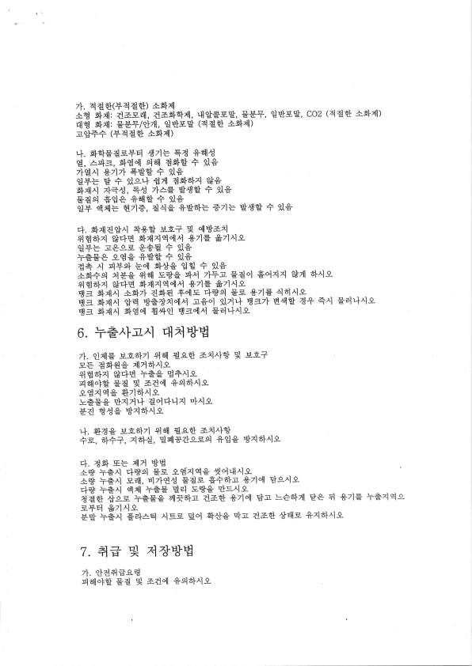
7I. zlee(+4ae) dq"4l
a€ r}rl], aa!-zl _{aasltrl4l,} ^{ql"Jggg,} trB+, ^{oJEls"J,} _{COZ} (446'J aE}^I) ^{q103} alzll: EE#/qlzL ^{oJqls"J} (4e+ ^{Aqd)} r"Jif (+4ae aEl4l)
+. ^{g.ElEa-e+q} _{^J7l=} +a +EIc
€, rs}=, 4g"r'l Eirl dqB + 9l+
z}€rl *z)zl +Be + 9l+
_{"J+=} B + ^{gls'I} Azl dqslx] **
4zlrl ^{zI*C, qC 7I^E g^Jg} + Xl+
EAE E"JE +BTC ^{+ 9i+ .J+} _{"l8l=} Bzl?, a4g +86'Its +71ts E^Je + 9l+
4. slznd*^l ++B ^{Bn+} 'i el*=;ll
+l€6};<1 f*trIQ $znxlq"I^l *zlE ^{*71^l-e- oJ+=} re ^{c.E} ++g + 9l+
+€Ee -qeg +,Je ^{+ il+} d* ^{rl q+e+} E"rl s}+g _{"Je} + 9l*.
AEI+E ,leg +lrll E+g 4rl zlFr Eaol q€6l,z1 ^{g+trIB q:I]xlqql^l} *zlE $zlrll
golxlxl _{9+zl} 6'i^ls
B= Elz]lrl 4EI7I a5+g +clE ^{trlB,el} Ee *zlE Er slrll^l *q _{"J+Ail"il^l} r+ol 9lZ+ $zzy
B= _{slz]]rl} q$"fl ^{,Ealql} Er"ll^l Eel'I^lg 6. f6'rlz{ ^{qla*B}
_{zI.} .J4lE _{-H_A6'I7] +16ll} g.cd _{axl^IEJ ",{} Eni ^{g=} d4flg 4lZ6}^19
+lql6lxi e*+E +69 B*49 ^{q6llolB} Ea 'i ^{adql +el6}^lg}
s-g;<l9€ +lzlalde
:r5.5.g *xlZuI dol4lxl ^{EI^IS} Ea €^dg *;<16l^lg
^{^l6l^]9-} B4B A+ +^l Eq+^ls
+. +49 u-=o121 _{+lall} g-c+ ^{=:'x1^I6J} +s, ^{6I++, zlEld,} Esl*Zlg-aq +'Jg Bzls}^lg
^{rl.} aq E= 4lZ %IB
A"6I ++^l 4"j=q E--E -gg7.lqg 4"].t-llxl-g
A"* ++^l s4, ^{ElzI€C} Ed-e €:+a}-n +7l"ll Bs^l-q
^{q4.} ++^l ^{.lnl} ++E Bq Eelg ^{qlE^ls}
aa": ^{,s.",e} _{+=€.€} zll{a}r aa+ *zlql Qr _{=*o}Al} ^{ge} I *zlE +=r.lqs -e+q #zlrlg
+"J +erl +r+^q ^{{=-e.} 'lq ^{qCg} _{"-}l.} d=-'J *EllE +46}^ls 7. _{atr} q _{4AlElH}
zI. ^{"Jd,#lB,C€ q"]]olB} _{Ea} q aaol +elE}^ls
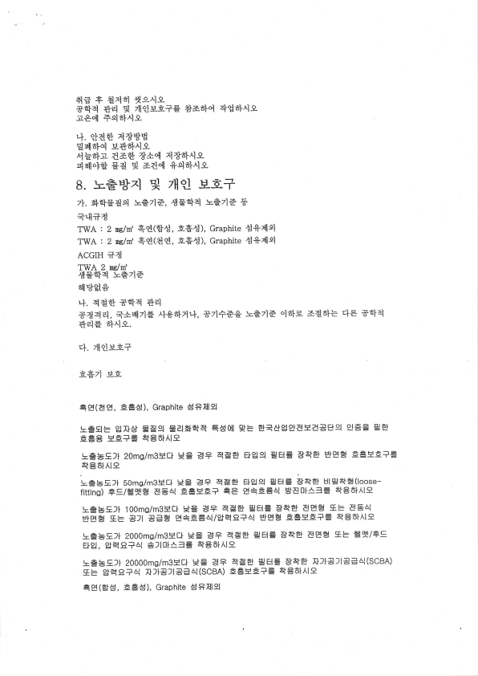
aE' + ^{a7l6l 4_s-^l-e-} _{Sq4 +"1} ,t _{ZlqlBE+E +a6}q} zlg6}^ls
r€..tl +q6l^lg
_{'1.} .Jdfl _{4*HlB}
"Jql6}q ^{tr+6}^l-e-}
_{^lE6I!.} Aa* tAol 4+61^ls
_{4allot€} gA _{"t} aa"il +eli}^lg
8. _{l==u};<]} q ^{zH} ?l 3-E+
zI. 448€9 :.<zl=, _{^JEo+zl} l=€7]6 5l
8.]1+4
_{TWA} : 2 ne/nf +€(BC, EEC), Graphite d+4lsl
TWA : 2 whn' +€(A€, a$^d), Graphite d+4l9
ACGIH ;1A
TWA ^{2 nc/nt'} c€.tr+4:==zlt
611'*s+
'I. ^{4etJ dltrI4 *fl}
*a4zl, ^{q^Ei7l=} _{^I*6izul,} *21;6€. :.,521= ^{ola|-tr-} aa6}= trI= _{+Elzi} +"lE 6I^l!-.
tr}, ,lldJ-BE+
EST] -H-E
=e(89, ^{aE8), Graphite AAIlsl}
_{-tEEts} ^{gllAt} Eeg ^{Ealtr+ql.4} _{=80t1} *= -dEA!ggrdEA=$9 E== _{"JA}
A=A EE?= EfE6lAl9.
l==.Ell 20ms/m3-tstl *= 3? 4trEj Elgel ^{EJB=} 8EA ^{HJEE} tr=Ea?E EE6l le
l=bEll. 50ms/m3Htl ^{9t=} =+ ^{4E-e! ElgE nJE=} 5t4ta ^{HloJ+E(loose} fittins) +=1gJ9!E E=^l ^{E=EA?} =3 ^{E+6=4} "JI!01^l= ^{4rE6lAl9} .t=EEll ^{10Oms/m3Htl} '*= ^{B+ 4trE! r'JB=} 84tE! AE-d E.ts 8E4 ^{UJEE} IEts _{B]I EA_d} g+6=^I/gq9+^I ^{BJEB} EEEET= EB6IAI9
!tr=EEll' 2000ms/m3Ett H= 3+ ^{4tr-e!} 'JE= ^{A+t-d &Ee .E=} gqi/FC ag, ^{g'qR+4} 6110t^l= +E6lAl9
!.EEEll 20000ms/m35eil HE _{BA 4tr:d} gBE _{84|.A &ll8llEBA(SCBA)} _{Ets} gqs+^l ftll.=ltBa4(scBA) EEsaE?= EE6l le
_{=E(-st8,} Eg5), GraPhite EPIll9l
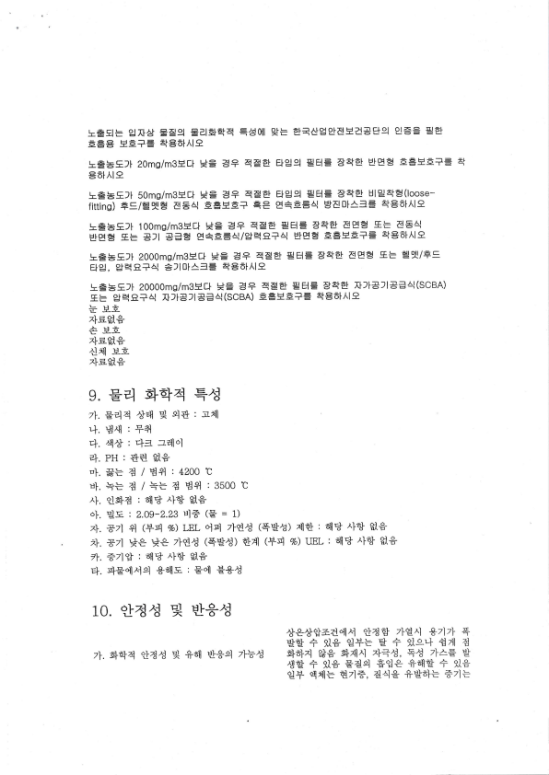
l=B= ^{gllat} =trel ^{EalFlqq} _{=/s0ll} '*= ^{a+c!ggfsEaEB9 E==} "JEl
E=E H.E?= 4rt6l^l9
l=5Ell 20ms/m3Etl *= B+ 4tr-d Elgel _{"JEl=} SsFA ^{HJE-d} E=HE+= + t6lAl9
l.=EEll SOms/m3Htl H= B+ 4€-d Elgq ^{EJEI=} 84:d HloJAr"tr(loose fittins) +E/4q!tr 8E^l ^{E=seE?} =e ^{g+E=4 gt[![l^==} 4f86t^l9 lEtsEll 100mg/m3Ett *= B? _{4tr-d} rJB= _{84'-d 8EB E= dE4} ^{BJEtr} Ets E]I _{BAE} g+6=4/g.qQ?^] ^{HJEE} E=.HE?= SIE6IAI9 l=bEll 2000ms/m3Htl H= A+ 4trei ^{rIJB=} 84r'E! aEE 5E= e9l/+E _{Elg,} ^{gr'qa+^l} *ll0l/'3= ^{q86l^l9.}
!.=BEll' 20000mg/m3Hti *= B+ 45eI ^{rJB=} SEtet Itll=ll=e^l(SCBA) ^{gE} Sqa+4 &ltB)lEa^I(SCBA) _{EEHE+=} qft6l^l9
^{Lil+} ;r ^{]{-9-} zls.S*
.a rj-6-
z|=.S*
4l^I !.E
zlE$,+
e. tr4 trltrlzl '+C
zI. Eflzl _{^"141} "i ^{sl+ : .a4l}
'1. ^{Exn :} *4
^{trI.} ^l+ ^{: rI= -zeilol}
_{zl.} pu : *€ S,*
_{"I.} #= e / _{Hgl} : 4200 t
EI.+=4/+=4Hel :3s00t
_{^I.} ql4d : 4'J _{^1.*} S+
ol. ^{oJ:a} : _{2.09-2.23} ul6 (tr ₌ ₁₎
_{^1.} *71 _{€l} (+q vd ^{LEL} _{"19} zI€C (+Bt) 4ld : 4'* _{^l6J} s+
. ^{71.} a7l *+ ** zlEa3 ^{(+g^d)} *al ^{(+q 7d \tEL: 6x'J} ^I.J ^{S'+} 71. _{+71"J} : ^{a1]'*} _{^I6J} S+
-,I. q+ql^l9 _{+BllE} : Eql B*^J
_{10.} qlec =i HI+c
++t}gaa.il^] _{"J4.J} zlg^l ^{-*zlzl} 4
BtJ + 9l* _{"J+=} B + 9ls'l A al C
_{7I.} qq4 ^{.Jac} 4 frall EI*sl 7I*^J 5+6}xl ?** slztlrl 4<c, Ec ^{z\+.E} B d.J + il+ EaE E"Je +sltJ + *+ _{.J+ "_qiil=} Bzl6, a4g +96l= +71=
"I. ^{4allo} B aa}
4. ^{qEIoI} E ^{gA}
4. EBi^l cc9E +BllBa 11. +C"I +6J 4u
BI^iltI -A olg
_{=.} ^{Ci} _{='} ^{I} ^AIf
€, lsl=, 4g F dElg zI€C Ed ^{z}*^d,} _{EC} zI: zleS.*
71. 7l+^aol E+ ]L,5 4E"ll +e _{'1.} arJ *.11c 4e
ia.rl ^{l=- il H ai- ai} 4+
4u
Bzlz} :=+ ₋₁ f,
^I ^{-r}
^{zleS,* zls$,+} (> 2820
zI+ *zlzJ l==
aq
^{tr dl} E- rl
q++.{c r= z}+c
d+ ts++ E= zI+C
^{a+zl4,Jrd} q++ElC
llloI-rl
_{=.rJ} d
_{4lg} qlaBaB
jr.+hE+!.^l
IARC
OSI'I-A
ACGIH
NTP
EU CLP
^B^l^tlsEolgC
^J^l+c
5a Ezi*zl 5c ⁽¹³¹ k€)
5;A s4*zl Erd _{1Eg-} :r.€) *t+Btc
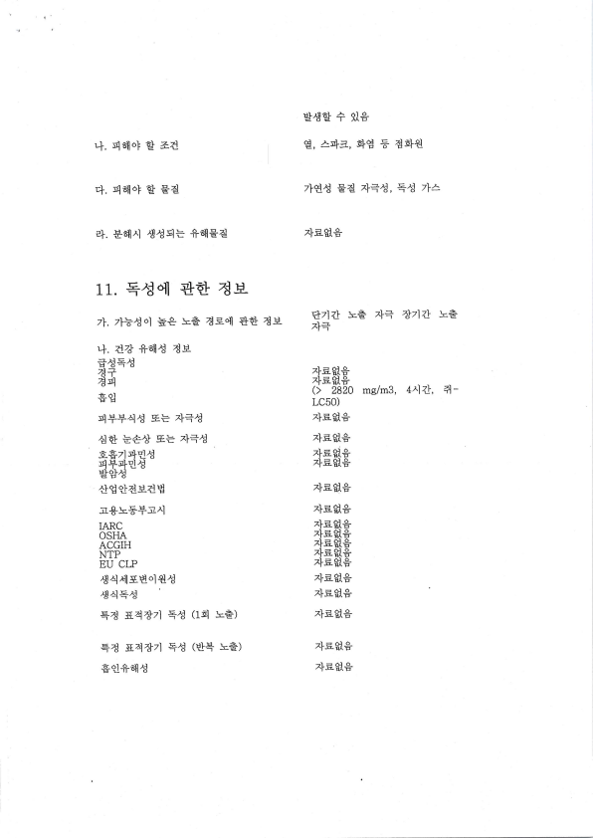
mg/m3, 4^1Zt, 4-
LC50)
zls.$,*
^{z|_tr} S,*
lisE3
_{^r.H-[} E
zls-$.*
zis_SS
^{z|tr"SS} zlssg _{zlgglS} ^{zle$.S} zls-S*
z}tr_S,$
zls.fl$
zl=.S*
x|_=-$,S
zls.S.*
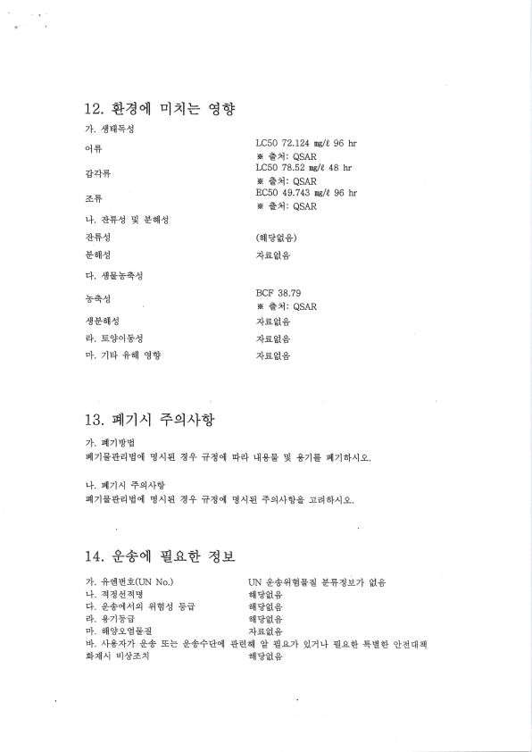
12. +aql ^{Elrl=} €'J zI. ^{rB45C}
q+
*4+
aF
+. ^{++C} "t ^{BBI^d}
&+c
Batl^d
^{El.} Cst'+€
^{-la.*.,rt} o ^{-'r-ci}
^JEE}IC
a1. c..*olEC
_{"I.} zl4 +"I ^{gt.J}
_{13"} qlTl^I _{+el^lo3} 7I. ^{qlTl%IB}
LC50 72.124 wl!,96 hr N €^l: QSAR
LC50 78.52 ms/{ 48 hr N €xl: QSAR
^{EC50 49.743} ry/4 96 hr ^{N} =z]: ^{QSAR}
(3ll'*s+)
4sB+
BCF 38.79
^{N} =xl: ^{QSAR}
^{,1-^16} ^rsE{E
zlss.+
zls_S*
slTlg+4B"]l B^l€ a+ +a"rl ^{I[l?+} _{'{+E} g _{*zlE} glzlo-},r1s.
+. ^{qlTl^l} +q^l6}
^{qlzlE+4H"I} B^l€ A+ +Aq E^l€ +q^l6J€;.21a1.,.19,
14. *+ql ^{g-q+} 4u_
^{7I.} +dHE(uN No.) uN *++lBEa E+4H7i S+ ^{,+.} 4Ad4E Erl'*gt*
^{q.} *+ql^lE +l€c Ff 6}]'*gt+
^{zl.} *zlF;. B]]"J-S,+
_{"1,} oX*sEEd _{4sH*}
u|..r|-$xlzl g+ _{E= s++Eql +€B1l} ^{.J} €.czl ilrl+ ^{g.s+} EE'+ ^{qlgErlzl} _{4ztlrr} El/}}ar] Btl'J"S,+
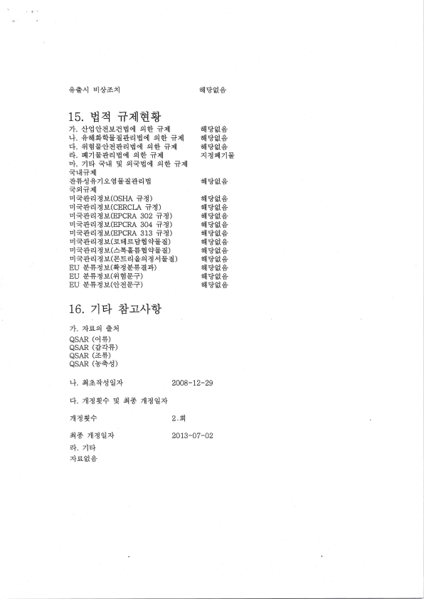
+=.^l ^{El+=;^l}
15. _{B} zl _{+4lBsJ} ^{71.} _{.ig.JasaHql} el* ₊₄₁ _{'1.} +iirl6+ga+elHql 9* +4
4. _{+lBs"Jd+4Hql} qd _{tr41} E}. qlTlE+elH"I ^{e.l+} ilal _{"1.} zl4 _{Er.ll} q _{E+H"ll} el'* _{ifzll} +ql+41
++^i f _{zlsB} ga+4 _{B}
+9ilrI
^{trl++zl4B(OSHA} +a)
^{El++44!-(CERCLA} ila) El++4atr(EPCRA _{302 it4)} "l++zlaB(EPCRA ³⁰⁴ ⁺⁴⁾ trlq+4aB(EPCRA _{313 +a)} El++4 _{a -H(EE]} sBE ^{.+EA)} ^{,,1++4} aH(^qgEE _{"+EA)} ^{El} _{E+4 4} s(gEq ^{gq} 4 _{^l} Ea)
EU ++8ts(q4E+a3+)
EU E+AE(+]BE+)
EU E+4.H.('JAE+)
16. 7lr-+ _{*-,:.,r1a3-} zI. 4sq €A
_{QSAR} (O]+)
_{QSAR} (*4+)
_{QSAR} (A+)
_{QSAR} (+rqC)
n]lB.fl+
Etl'*sg
3I*Sg 611=&S* xlaqlTlE
^{81lB} S,*
irl'Js+ itl'J$,* iiB-fls 8il"*ss Ell'+$.* Ell'*s+ EI"*S.+ BI'*S,S Btl'&ss Bi'&$.* rI"&$,9
4. A=4C.Jzl
_{4-.} ^{zll4q+} "t A+ 44oJ4 ,llA9+
4* zll4 9zI
e-1. zl4
zlsl$.*
2AAB-72-29
2.4
2A]3*07-A2

